**The Effect of Air Pollution on Risk of Hospital Readmission and Death among Cardiac Patients in Utah’s Medicare Population**

Claire L Leiser, Ken R Smith, James A VanDerslice, Jason P Glotzbach, Timothy W Farrell, Heidi A Hanson

**Abstract**

**Background**: Older adults are vulnerable to the effects of fine particulate matter (PM2.5) air pollution. We investigated the effect of PM2.5 on 30-day cardiac readmission and the competing risk of death among Medicare beneficiaries.

**Methods:** Hospitalizations for any cardiac condition, myocardial infarction (MI), heart failure (HF), ischemic heart disease (IHD), and cardiac arrhythmias from 1999-2009 were identified. Exposure was assigned based on residential zip code and various lag values (lag0, lag1, 3-day average, and 7-day average) were generated. Fine and Gray regression models jointly modeled the effect of PM2.5 on readmission hazard rates while allowing for the competing risk of death. Models were stratified by age group and sex.

**Results:** Among ages 75-84, a 10 μm/m3 increase in 3-day average exposure to PM2.5 was the most consistent predictor of adverse health outcomes. For males, it was associated with a 17% increase in the relative risk of death within 30 days of an HF hospitalization. A 10 μm/m3 increase in PM2.5 was associated with a 34% decreased risk for cardiac readmission, however this was explained by the accompanying 35% increase in risk of death. Similarly, females hospitalized for IHD had a 25% decrease in risk of cardiac readmission and a 35% increase in risk of death. PM2.5 was associated with a 29% increase in 30-day readmission for females admitted for HF.

**Conclusions:** Exposure to PM2.5 was associated with an increased risk of readmission and death. The associations were dependent upon age, sex, and severity of the index condition.

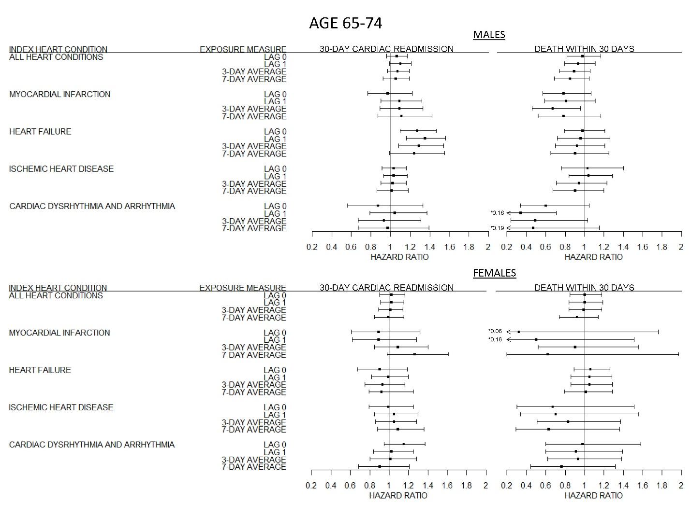

**Figure 1:** The effect of fine particulate matter (PM2.5) air pollution on 30-day cardiac readmission and death by index admission and sex among cardiovascular patients age 65-74 in Utah’s Medicare Population from 1999-2009. Results of Fine and Gray regression. All results jointly estimate the risk of readmission or mortality while adjusting for the competing risk of readmission from a non-cardiac related cause. Error bars indicate 95% confidence intervals.

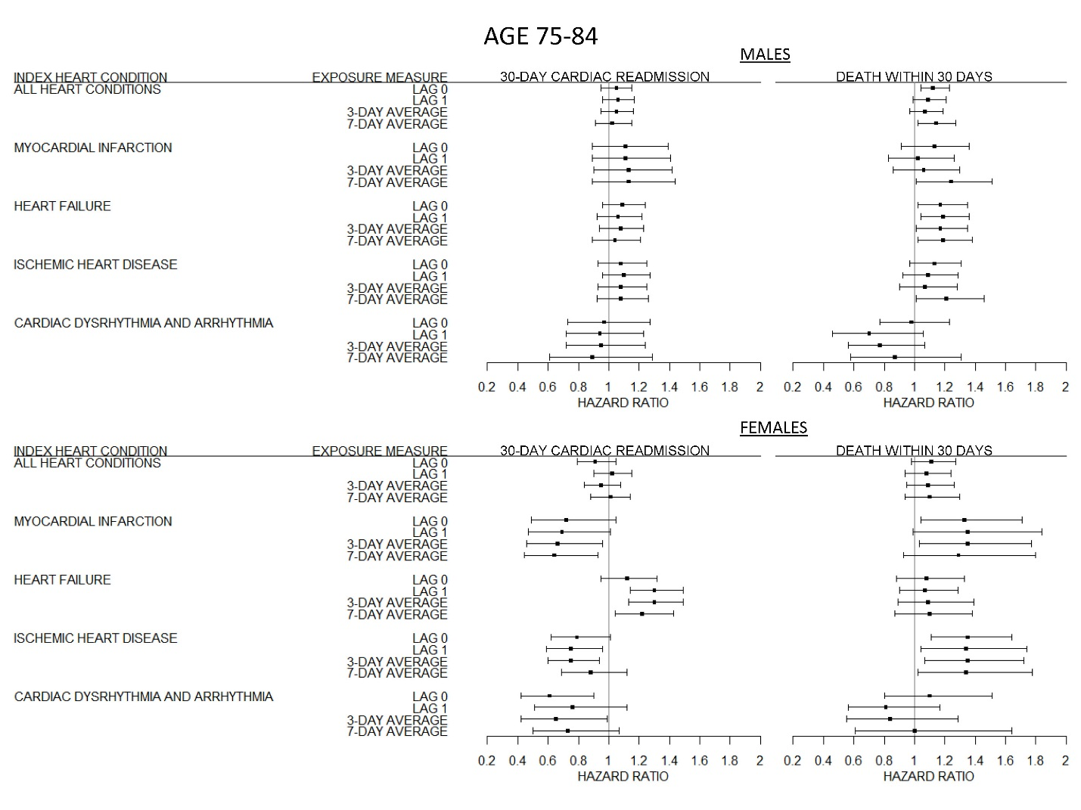

**Figure 2:** The effect of fine particulate matter (PM2.5) air pollution on 30-day cardiac readmission and death by index admission and sex among cardiovascular patients age 75-84 in Utah’s Medicare Population from 1999-2009. Results of Fine and Gray regression. All results jointly estimate the risk of readmission or mortality while adjusting for the competing risk of readmission from a non-cardiac related cause. Error bars indicate 95% confidence intervals.

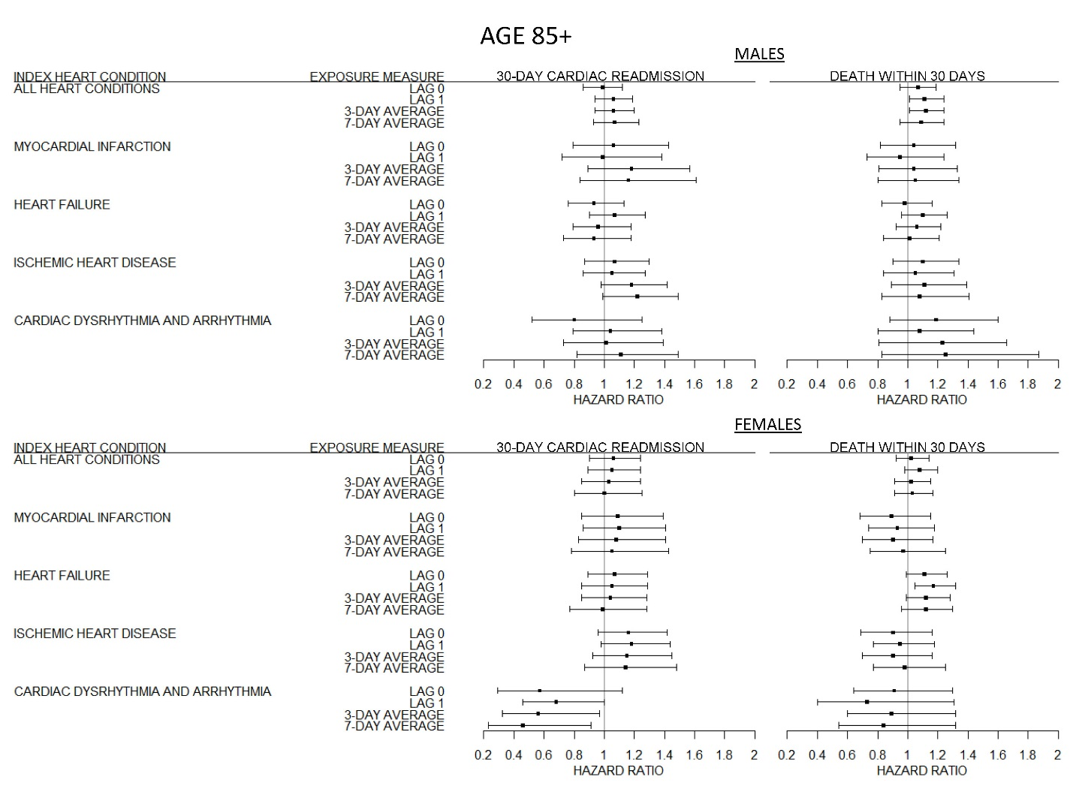

**Figure 3:** The effect of fine particulate matter (PM2.5) air pollution on 30-day cardiac readmission and death by index admission and sex among cardiovascular patients age 85+ in Utah’s Medicare Population from 1999-2009. Results of Fine and Gray regression. All results jointly estimate the risk of readmission or mortality while adjusting for the competing risk of readmission from a non-cardiac related cause. Error bars indicate 95% confidence intervals.